

**ELECTRONIC VOYAGE REPORT**

**SYSTEM OPERATION DOCUMENT**

**MAB/GROUP IT/SOD/EVR/2.1**

**ALL INFORMATION CONTAINED HEREIN IS RESTRICTED AND SHALL BE KEPT FOR INTERNAL USE ONLY**. None of this information shall be divulged to persons other than Malaysia Airlines Berhad employees and contractors authorized by the nature of their duties to receive such information, or individuals or organisations authorised by Malaysia Airlines Berhad in accordance with existing policy regarding release of company information.

**INTENTIONALLY LEFT BLANK**

|  |  |  |  |
| --- | --- | --- | --- |
|  |  |  |  |
| Prepared By | : |  |  |
|  |  | RajashekarReddy Kasireddy |  |
|  |  | EVR Support Team |  |
|  |  | Application Management Services |  |
|  |  |  |  |
| Reviewed By | : |  |  |
|  |  | Khairuddin Mohamed Sidek  Assistant Manager  GTO – Information Technology |  |
|  | : | Mohd Jaafar Abdul Rahman |  |
|  |  | OPS Captain Flight Crew  OPS - Flight Operations |  |
|  |  | Wan Mohd Husni Wan Hussein  AMS SDM  Application Management Services |  |
|  |  |  |  |
| Approved By | : |  |  |
|  |  | Siti Hafsah Mohd Desa |  |
|  |  | Head IT SDM |  |
|  |  | Group IT |  |

**INTENTIONALLY LEFT BLANK**

**TABLE OF CONTENTS**

**Contents Page**

**PART 1 – MANUAL ADMINISTRATION 1-1**

[1.1 RECORD OF REVISION 1-2](#_Toc502738111)

[1.2 LIST OF EFFECTIVE PAGES 1-3](#_Toc502738112)

[1.3 DISTRIBUTION LIST 1-4](#_Toc502738113)

[1.4 LIST OF ABBREVIATIONS 1-4](#_Toc502738114)

[1.5 CONDITION OF USE 1-5](#_Toc502738115)

[1.6 CONTROL OF MANUAL 1-5](#_Toc502738116)

[2.1 INTRODUCTION 2-2](#_Toc502738117)

[2.2 PURPOSE 2-2](#_Toc502738118)

[2.3 SCOPE AND APPLICATION 2-2](#_Toc502738119)

[2.4 DEFINITION OF TERMS 2-2](#_Toc502738120)

[3.1 OVERVIEW OF BUSINESS PROCESS 3-2](#_Toc502738121)

[4.1 SYSTEM OVERVIEW 4-2](#_Toc502738122)

[4.1.1. EVR Cabin Crew 4-2](#_Toc502738123)

[4.1.2. EVR Technical Crew 4-2](#_Toc502738124)

[4.2 SYSTEM CONCEPT DIAGRAM 4-](#_Toc502738125)3

[4.2.1. EVR Cabin Crew Concept Diagram 4-](#_Toc502738126)3

[4.2.2. EVR Technical Crew Concept Diagram 4-](#_Toc502738127)3

[4.3 INTERFACES 4-](#_Toc502738128)4

[4.3.1. User Interfaces 4-](#_Toc502738129)4

[4.3.2. System Interfaces 4-](#_Toc502738130)4

[4.4 WARRANTY AND MAINTENANCE PERIOD 4-](#_Toc502738131)4

[4.5 ROLES AND RESPONSIBILITIES 4-4](#_Toc502738132)

[4.6 TECHNICAL SPECIFICATIONS 4-](#_Toc502738133)5

[4.6.1. Hardware Specifications 4-](#_Toc502738134)5

[4.6.2. Software Specifications 4-5](#_Toc502738135)

[4.6.3. Communication / Network Specification 4-5](#_Toc502738136)

[4.6.4. User And Equipment Locations 4-](#_Toc502738137)6

[4.6.5. File Management 4-](#_Toc502738138)6

[4.6.5.1. Libraries And Files 4-](#_Toc502738139)6

[4.6.5.2. DBMS setup 4-6](#_Toc502738140)

[4.7 TECHNICAL OPERATIONS GUIDE 4-](#_Toc502738141)7

[4.7.1. Installation Procedures 4-](#_Toc502738142)7

[4.7.2. Backup And Recovery 4-](#_Toc502738143)7

[4.7.3. System Startup and restart 4-](#_Toc502738144)8

[4.7.4. System Shutdown 4-](#_Toc502738145)9

[4.7.5. MONITORING Tools 4-](#_Toc502738146)9

[4.7.6. Source Code Version Control 4-](#_Toc502738147)9

[4.7.7. Preparation Of Production Environment 4-](#_Toc502738148)9

[4.7.7.1. Network Definitions 4-](#_Toc502738149)9

[4.7.7.2. Desktop Configuration 4-](#_Toc502738150)9

[4.7.8. Baseline Performance Information 4-](#_Toc502738151)9

[4.8 MAINTENANCE AND SUPPORT 4-](#_Toc502738152)10

[4.8.1. Problem Solving 4-](#_Toc502738153)10

[4.8.1.1 Frequent Issues and Resolutions 4-](#_Toc502738154)10

[4.8.1.2 Finding Logs and Tracking issues 4-](#_Toc502738155)10

[4.8.2. Problem Categorization and Escalation 4-](#_Toc502738156)10

[4.8.3. Application / Technical Support 4-1](#_Toc502738157)1

[4.9 USER GUIDE 4-1](#_Toc502738158)1

[4.9.1. EVR CCF User Guide 4-1](#_Toc502738159)1

[4.9.2. EVR TCF User Guide 4-1](#_Toc502738160)1

[4.9.2.1 ELOGBOOK 4-1](#_Toc502738160)2

4.9.2.2 ADMIN 4-16

4.9.2.3 SCHEDULED JOBS 4-21

[4.10 ACCESSING THE APPLICATION 4-](#_Toc502738161)21

[4.11 CONTRACT MANAGEMENT 4-](#_Toc502738162)21

[4.12 HANDOVER ITEMS 4-](#_Toc502738163)22

[4.13 INFORMATION SECURITY 4-](#_Toc502738164)22

[4.13.1. Audit And Compliance Requirements 4-](#_Toc502738165)22

[4.13.2. Password And Policy Compliance 4-](#_Toc502738166)23

[4.13.3. User Access Matrix 4-](#_Toc502738167)23

[DOCUMENTATION AND REFERENCES 4-](#_Toc502738168)24

[APPENDIX i](#_Toc502738169)

1. - MANUAL ADMINISTRATION

# RECORD OF REVISION

| **No.** | **Description Of Changes** | **Issue No.** | **Revision No.** | **Author** | **Effective Date** |
| --- | --- | --- | --- | --- | --- |
| 1 | Original | 1 | 0 | Yuvarani | 29-Apr-16 |
| 2 | Updated CCF System owner details | 1 | 1 | RajashekarReddy Kasireddy | 27-Sep-19 |
| 3 | Updated application support details | 1 | 1 | RajashekarReddy Kasireddy | 27-Sep-19 |
| 4 | Updated Change Numbers | 1 | 1 | RajashekarReddy Kasireddy | 29-May-2020 |
| 5 | Update eLogbook and admin new functionalities | 2 | 1 | RajashekarReddy Kasireddy | 07-May-2021 |

# LIST OF EFFECTIVE PAGES

|  |  |  |  |  |  |  |  |  |  |  |
| --- | --- | --- | --- | --- | --- | --- | --- | --- | --- | --- |
| **Part** | **Page** | **Issue No.** | **Revision No.** | **Effective Date** |  | **Part** | **Page** | **Issue No.** | **Revision No.** | **Effective Date** |
| 1 | 1-1 | 1 | 0 | 29-04-16 |  |  | 4-18 | 2 | 1 | 03-05-21 |
|  | 1-2 | 2 | 1 | 07-05-21 |  |  | 4-19 | 2 | 1 | 07-05-21 |
|  | 1-3 | 2 | 1 | 07-05-21 |  |  | 4-20 | 2 | 1 | 07-05-21 |
|  | 1-4 | 2 | 1 | 07-05-21 |  |  | 4-21 | 2 | 1 | 07-05-21 |
|  | 1-5 | 1 | 0 | 29-04-16 |  |  | 4-22 | 1 | 3 | 28-12-17 |
|  | 1-6 | 1 | 0 | 29-04-16 |  |  | 4-23 | 1 | 3 | 28-12-17 |
| 2 | 2-1 | 1 | 0 | 29-04-16 |  |  | 4-24 | 1 | 3 | 28-12-17 |
|  | 2-2 | 1 | 0 | 29-04-16 |  |  |  |  |  |  |
| 3 | 3-1 | 1 | 0 | 29-04-16 |  |  |  |  |  |  |
|  | 3-2 | 1 | 0 | 29-04-16 |  |  |  |  |  |  |
| 4 | 4-1 | 1 | 0 | 29-04-16 |  |  |  |  |  |  |
|  | 4-2 | 2 | 1 | 07-05-21 |  |  |  |  |  |  |
|  | 4-3 | 1 | 0 | 29-04-16 |  |  |  |  |  |  |
|  | 4-4 | 1 | 3 | 28-12-17 |  |  |  |  |  |  |
|  | 4-5 | 2 | 1 | 07-05-21 |  |  |  |  |  |  |
|  | 4-6 | 2 | 1 | 07-05-21 |  |  |  |  |  |  |
|  | 4-7 | 2 | 1 | 07-05-21 |  |  |  |  |  |  |
|  | 4-8 | 1 | 0 | 29-04-16 |  |  |  |  |  |  |
|  | 4-9 | 2 | 1 | 07-05-21 |  |  |  |  |  |  |
|  | 4-10 | 2 | 1 | 07-05-21 |  |  |  |  |  |  |
|  | 4-11 | 1 | 0 | 29-04-16 |  |  |  |  |  |  |
|  | 4-12 | 2 | 1 | 07-05-21 |  |  |  |  |  |  |
|  | 4-13 | 2 | 1 | 07-05-21 |  |  |  |  |  |  |
|  | 4-14 | 2 | 1 | 07-05-21 |  |  |  |  |  |  |
|  | 4-15 | 2 | 1 | 07-05-21 |  |  |  |  |  |  |
|  | 4-16 | 2 | 1 | 07-05-21 |  |  |  |  |  |  |
|  | 4-17 | 2 | 1 | 07-05-21 |  |  |  |  |  |  |
|  |  |  |  |  |  |  |  |  |  |  |

# DISTRIBUTION LIST

|  |  |  |
| --- | --- | --- |
| **NAME** | **DEPT / AREA** | **DESIGNATION** |
| Capt Mohd Jaafar Abdul Rahman @ Aman | OPS - Flight Operations | System Owner |
| Siti Hafsah Mohd Desa | Group IT | HEAD IT SDM |
| Wan Mohd Husni Wan Hussein | AMS | AMS SDM |

Table 1

# LIST OF ABBREVIATIONS

The following are the abbreviations used for the purpose of simplification.

|  |  |
| --- | --- |
| **Abbreviation** | **Denote** |
| EVR | Electronic Voyage Report |
| CCF | Cabin Crew Form |
| TCF | Technical Crew Form |
| CCVR | Cabin Crew Voyage Report |
| TCVR | Technical Crew Voyage Report |

Table 2

# CONDITION OF USE

* + 1. This manual is the property of Malaysia Airlines Berhad.
    2. All copies assigned to individual position(s), section(s) or station(s) is on loan basis. If, for any reason, the position(s), section(s) or station(s) is abolished from the company organization, the respective copy(ies) of the manual must be returned to Head IT service Delivery Manager.
    3. In the event where the title of the position or section is changed, the department concerned shall inform (Head IT service Delivery Manager) promptly.
    4. The content of this manual shall not be copied, or communicated in part or as a whole, to any person(s) not employed by the Company without the express written consent of the Head IT service Delivery Manager.
    5. It is the responsibility of the holder to ensure that his/her copy is updated to the latest amendment and is in good state of condition.

# CONTROL OF MANUAL

* + 1. The contents of this manual shall not be deleted, added, or altered in anyway without the approval of the Head IT service Delivery Manager.
    2. Any page which carries an amendment must bear the new revision date. Any line which is amended shall be highlighted by a revision bar (i.e. dark vertical line) drawn close to the amended text on the outside border of the document.
    3. A transmittal letter must accompany the amended pages to advise the holders how to effect the amendment to their copies.
    4. Holders shall notify this department in writing for loss of manual and to obtain a replacement copy.
    5. Head IT service Delivery Manager shall ensure that this manual is reviewed at least once a year and effect necessary amendments as and when necessary. Should any person(s) envisage improvements needed for the contents of this manual, the person should direct the request to Head IT service Delivery Manager.

INTENTIONALLY LEFT BLANK

1. - MANUAL BACKGROUND

# INTRODUCTION

This is the EVR SOD, hereinafter referred to as “the Policy” provides comprehensive operating procedures within the scope and application herein defined in Part 2 Section 3.0 for Malaysia Airlines Berhad (MAB).

# PURPOSE

The objective of this document is to provide relevant information required to operate and support a completed project, ready for implementation and handover to IT Operations.

# SCOPE AND APPLICATION

This document covers relevant information required to operate and support the EVR system in production environment. This covers the maintenance operation of the system, database and interfaces.

# DEFINITION OF TERMS

|  |  |  |
| --- | --- | --- |
| **S.No** | **Term** | **Description** |
| 1 | CCF | Cabin Crew Form |
| 2 | TCF | Technical Crew Form |
| 3 | TCVR | Technical Crew Voyage Report |
| 4 | VR | Voyage Report |
| 5 | CCIC | Cabin Crew In-Charge |
| 6 | SRAS | Small Rapid Application System |
| 7 | AODB | Airport Operation Database |
| 8 | LDAP | Light Weight Directory Access Protocol |

Table 3

1. – OVERVIEW OF BUSINESS PROCESS

# OVERVIEW OF BUSINESS PROCESS

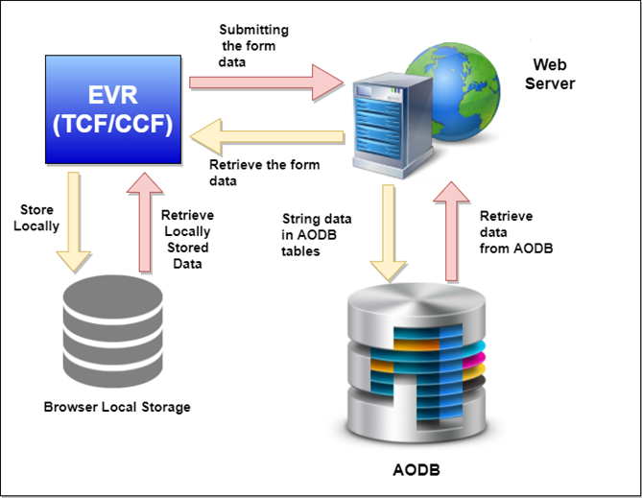

Figure 1

1. - MANUAL CONTENT TITLE

# SYSTEM OVERVIEW

EVR includes Cabin and Technical Crew VR applications. It is widely used in Operation Department by Cabin Crew and Technical Crew Team. We have progressed further and we are now moving away from the manual entry form to an automated form. EVR is also designed to be accessible without internet connection on board the flight.

### 4.1.1. EVR Cabin Crew

* Cabin Crew Voyage Report (CCVR) is used by Cabin Crew in-charge on flights to report the flight details, Cabin crew staff details, and Service and Passenger incident reports for each flight sector.
* CCVR is used to capture all service breakages on board and also any other relevant issues affecting the passengers/customers and the cabin crew.
* CCVR is also used to do Performance Assessment for Cabin Crew Staffs.
* CCIC is responsible in reporting the Voyage Report and also responsible for the timely submission of the said Voyage Report.
* CCVR must be submitted for every sector and CCICs must ensure that all breakages is captured and reported in the VR accordingly.

### 4.1.2. EVR Technical Crew

* Technical Crew Voyage Report (TCVR) is used by Captain on flights to report the flight and fuel information for each voyage.
* The Captain is responsible in reporting the Voyage Report and also responsible for the timely submission of the said Voyage Report.
* The application is used to track fuel details for the flight, working hours of each pilot and flight delay information.
* The details will be used by respective Business Units for auditing and tracking purpose.
* EVR Missing crew info implemented to identify the flights crew missing. Schedule Job run by Morning 7 am and evening 7pm everyday and notify the information to NCMS team to trigger crew data.
* The application has eLogbook report for the staff to get their past experience, other flying information, evr submitted form list, simulator details and manual certification data.
* The total hours in manual certification should be equal to other flying info hours.

# SYSTEM CONCEPT DIAGRAM

### 4.2.1. EVR Cabin Crew Concept Diagram

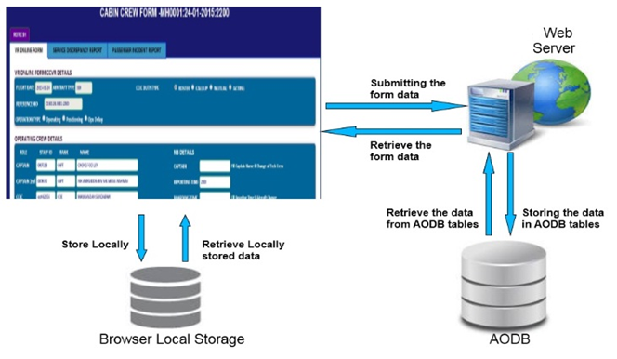

Figure 2

### 4.2.2. EVR Technical Crew Concept Diagram

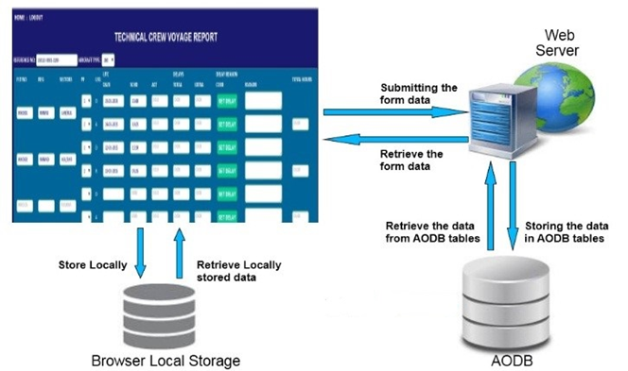

Figure 3

# INTERFACES

### 4.3.1. User Interfaces

* Google Chrome is the recommended browser to access EVR application as it offers best suitability and stability in working offline.
* The usage of Internet Explorer, Mozilla Firefox, Safari and Opera is optional as it does not provide the same stability offered by the Google Chrome.

### 4.3.2. System Interfaces

* The application is using LDAP to authenticate user while login into application. User can login into application using MH domain credentials and it will be validated using LDAP validator.

# WARRANTY AND MAINTENANCE PERIOD

NA

# ROLES AND RESPONSIBILITIES

| **Role** | **Responsibilities** |
| --- | --- |
| Midrange Team | * Responsible for maintaining web server. * Responsible for troubleshooting infrastructure related problems. |
| DBA Team | * Responsible for maintaining database |
| Application Support  (AMS) | * Responsible for uploading application in web server * Responsible for monitoring system performance * Responsible for providing application support * Responsible for deploying application and publishing it to user. * Responsible for maintaining EVR application second level support |
| MAB Helpdesk | * As single point of contact to coordinate when EVR problems occurred. * Responsible to coordinate problem reporting to the respective supporting team. |

Table 4

# TECHNICAL SPECIFICATIONS

### 4.6.1. Hardware Specifications

**Application Servers:**

|  |  |  |  |  |  |  |  |
| --- | --- | --- | --- | --- | --- | --- | --- |
| **Hostname** | **IP Address** | **Environment** | **Server Function** | **Location** | **CPU** | **RAM(GB)** | **Processor Speed** |
| MASG-1EVRAPP1 | 10.221.4.49 | Production | Application | Azure VM (Public cloud-  Singapore) | 2 | 7 | E5-2673 v3 @ 2.40GHz |
| MASG-1EVRWEB1 | 10.221.2.11 | Production | Web | Azure VM(Public cloud-  Singapore) | 2 | 7 |
| MASG-3EVRAPP1 | 10.221.12.9 | UAT | Application | Azure VM (Public cloud-  Singapore) | 2 | 4 |
| MAHK-2EVRAPP1 | 10.222.4.13 | DR | Application | Azure VM(Public cloud-Hong Kong) | 2 | 7 |
| MAHK-2EVRWEB1 | 10.222.2.7 | DR | Web | Azure VM(Public cloud-  Hong Kong | 2 | 7 |

Table 5

### 

### 4.6.2. Software Specifications

|  |  |  |
| --- | --- | --- |
|  | **Software** | **Specification** |
|  | Web Server | Apache – 2.4.23 |
|  | Application Server | Apache Tomcat – 9.0.36 |
|  | Database | DB2 |
|  | Front-end | Chrome 18+(Recommended), Safari 5+, Opera 9+ |

Table 6

### 4.6.3. Communication / Network Specification

|  |  |  |
| --- | --- | --- |
| **Hostname/DNS** | **IP address** | **Description** |
| MASG-1EVRAPP1 | 10.221.4.49 | Prod Application Server |
| MASG-1EVRWEB1 | 10.221.2.11 | Prod Web Server |
| MASG-3EVRAPP1 | 10.221.12.9 | Test Application Server |
| MAHK-2EVRAPP1 | 10.222.4.13 | DR Application Server |
| MAHK-2EVRWEB1 | 10.222.2.7 | DR Web Server |
| 1AODB.MAS.NET | 10.223.6.118 | Prod DB server |
| 3AODB1.MAS.NET | 10.224.22.32 | Test DB server |

Table 7

### 4.6.4. User And Equipment Locations

EVR applications are published in the open internet with the secured certificate and can accessible from all MAB locations as well as from open internet.

### 4.6.5. File Management

### 

|  |  |
| --- | --- |
| **Libraries and files** | **Location/Mount Points** |
| Tomcat related files | /home/tomcatadmin /tomcat |
| Apache related Library | /usr/local/apache /home/appadmin |

Table 8

##### 4.6.5.1. Libraries And Files

The EVR Cabin Crew code is in /tomcat/apache-tomcat-9.0.36/webapps/EVR\_CCF in 1evrapp1.mas.net and 3evrapp1.mas.net Tomcat server.

The EVR Technical Crew code is in /tomcat/apache-tomcat-9.0.36/webapps/EVR\_TCF in 1evrapp1.mas.net and 3evrapp1.mas.net Tomcat server.

##### 4.6.5.2. DBMS setup

|  |  |  |
| --- | --- | --- |
| **AODB – TCF** | | |
| DB Path | EVR TCF Table | Description |
| 1AODB.MAS.NET | TCR\_AUTHORIZATION | Used to store details of captain who submits the VR. |
| TCR\_FLIGHT\_FUEL\_INFO | To store the fuel information of flight. |
| TCR\_FUEL\_INFO | To store the fuel information of flight. |
| TCR\_NCMS\_STAFF\_INFO | Contains staff details of particular VR |
| TCR\_STAFF\_INFO | Contains staff details of particular VR |
| TCR\_TRACKER\_INFO | To track submitted VR status. |
| TCR\_USER\_LIST | Used to store user details of Technical Crew application. |
| EVR\_TCF\_SIMULATOR | To store the simulator hours. |
| EVR\_TCF\_ADDRESS | To store the current and updated address. |
| EVR\_TCF\_PAST\_EXPERIENCE | To store the past experience of the staff. |
| EVR\_TCF\_CERTIFICATE | To store the certificate for the staff. |
| EVR\_TCF\_OTHER\_FLYING | To store the other flying data of the staff. |
| EVR\_TCF\_MANUAL\_CERTIFICATION | To store the manual certification data for staff. |
| EVR\_TCF\_LICENSE | To store current and updated license. |

Table 9

|  |  |  |
| --- | --- | --- |
| **AODB –CCF** | | |
| DB Path | EVR CCF Table | Description |
| 1AODB.MAS.NET | EVR\_FORM\_LOAD\_STATUS | Contains status of form and crew details who loads the form. |
| EVR\_VOYAGE\_REPORT | Contains CCIC and captain details |
| EVR\_FLGHT\_DTL | Contains the details of flight timings. |
| EVR\_FLGHT\_CREW\_DTL | Contains the details of crew for the flight |
| EVR\_CABIN\_CREW\_CHKLIST | Contains Cabin Crew Checklist status |
| EVR\_SERVICE\_DISC | To store service discrepancy details |
| EVR\_SERVICE\_DISC\_PROOF | To store the image of service discrepancy report. |
| EVR\_PAX\_INCIDENT | To store passenger incident details |
| EVR\_PAX\_INCIDENT\_DISC\_PROOF | To store the image of passenger incident report. |
| EVR\_TRACKER\_INFO | Used to track the flight details and form submitted CCIC details. |
| EVR\_REPORT\_INFO | To store the parameter for report generation. |

Table 10

# TECHNICAL OPERATIONS GUIDE

### 4.7.1. Installation Procedures

* Application will be deployed in Tomcat Server in war file format by AMS and Infra Team. The below is the Tomcat Server URL.

**AMS:** 3evrapp1.mas.net:8080/Deploymanager/html

**INFRA:** 1evrapp1.mas.net:8080/Deploymanager/html

* Database setup is done through DB2.

### 4.7.2. Backup And Recovery

Application is being backed using DR server. Database will be backed up on daily basis.

**Azure VM Backup**

Azure recovery Services vault is an entity that stores all the backups and recovery points that have been created over time. The vault also contains the backup policies that will be applied to the virtual machines being backed up

When the Recovery services initiates a backup job at the scheduled time, it triggers the backup extension to take a point-in-time snapshot. The Azure Recovery service uses the VMSnapshot extension in Windows, and the VMSnapshotLinux extension in Linux. The extension is installed during the first VM backup.

Once the Azure Backup service takes the snapshot, the data is transferred to the vault. To maximize efficiency, the service identifies and transfers only the blocks of data that have changed since the previous backup.

When the data transfer is complete, the snapshot is removed and a recovery point is created

**OS Backup:**

|  |  |  |  |  |
| --- | --- | --- | --- | --- |
| **Hostname** | **# of Versions** | **Frequency** | **Schedule** | **Remarks** |
|
| MASG-1EVRAPP1 | 6 | Every Saturday | 5.30 PM MYT | Monthly first Saturday backup retention is 3 months |
| MASG-1EVRWEB1 | 6 | Every Saturday | 5.30 PM MYT | Monthly first Saturday backup retention is 3 months |
| MASG-3EVRAPP1 | 4 | Every Saturday | 5.30 PM MYT | Monthly first Saturday backup retention is 2months |
| MAHK-2EVRAPP1 | 5 | Every Saturday | 8:00 PM MYT | Monthly first Saturday backup retention is 2months |
| MAHK-2EVRWEB1 | 5 | Every Saturday | 8:00 PM MYT | Monthly first Saturday backup retention is 2months |

Table 11

**Database Backup:**

|  |  |  |  |  |
| --- | --- | --- | --- | --- |
| **Hostname** | **# of Versions** | **Frequency** | **Schedule** | **Remarks** |
| CX2-1AODB1 | IBM DB2 11.5 | Everyday | 12 AM MYT | Backup retention is 15 days |

Table 12

### 4.7.3. System Startup and restart

DB2 Database and EVR Application services are set to startup automatically after installation

If manual start/stop of services are required, it should be performed in the following manner:-

* + Login to server using console access.
  + Start the Tomcat in application server and apache services in Web server using below commands

→/tomcat/apache-tomcat-9.0.36/bin/startup.sh

→/usr/local/apache/bin/apachectl start

* + Start DB2 Server

### 

### 4.7.4. System Shutdown

* + Login to server using console access.
  + Stop the Tomcat in application server and apache services in Web server using below commands

→/tomcat/apache-tomcat-9.0.36/bin/shutdown.sh

→/usr/local/apache/bin/apachectl stop

* + Stop DB2 Server

### 4.7.5. MONITORING Tools

EVR servers unavailability, URL monitoring, Process monitoring are done by IBM Tivoli monitoring

For EVR related Servers/Applications monitoring refer – TEC (Tivoli Escalation Procedure)

### 4.7.6. Source Code Version Control

EVR is the only repository that needs to be put into version control. Other configuration files need not be in version control.

Below is the procedure for handling the Source Code for EVR supported by AMS team:

* Take the latest code into test environment.
* Development and testing is done in the test environment.
* UAT is perform in the test environment

Upon confirmation, the current version in the production will be backup then the new version is deployed into production.

### 4.7.7. Preparation Of Production Environment

##### 4.7.7.1. Network Definitions

EVR Applications are hosted in the open network and user can access the application from any location without the VPN.

##### 4.7.7.2. Desktop Configuration

* Web Browser with Java enabled.

### 4.7.8. Baseline Performance Information

|  |  |  |
| --- | --- | --- |
| **S.No.** | **Activity** | **Expected Response Time** |
| 1. | Average time to generate response to requests | 1 second |
| 2. | Average time taken to load each page | < 60 seconds |

Table 13

Downtime during operation hours is 30 minutes.

# MAINTENANCE AND SUPPORT

### 4.8.1. Problem Solving

Users will log any problem pertaining EVR to Helpdesk by telephone call or by sending mail to HELPDESK.

Helpdesk will be equipped with guidelines on how to perform 1st level troubleshooting and log problem accordingly.

**4.8.1.1 Frequent Issues and Resolutions**

|  |  |
| --- | --- |
| **Issue** | **Resolution** |
| Cannot load the Login Page | Check your internet connection . |
| Cannot load Home Page for VR Upload | Please ensure you key in correct password. |
| EVR already submitted by other person | Contact Khairuddin Mohamed Sidek Cabin Crew to reactivate the VR. |
| EVR Reference number already exists | Contact Mohd Jaffar Abdul Rahman to resolve this issue. |

Table 14

##### 4.8.1.2 Finding Logs and Tracking issues

* Get the EVR log file from the path /Apache-Tomcat/apache-tomcat-8.0.24/logs.
* Track the error log in the log file based on reference number.

### 4.8.2. Problem Categorization and Escalation

Helpdesk will analyze the problem and assign a ticket number and a severity level which is mutually agreed by the user. However, the severity will be revised downward based on business assessment and impact as shown below

|  |  |  |
| --- | --- | --- |
| **Severity** | **Code** | **Definition of Severity Level** |
| Critical | S1 | Total Biz Operation Disruption |
| High (Urgent) | S2 | Partial Biz Operation Disruption |
| Moderate (Minor) | S3 | No critical impact to Biz operations, Workaround is available |
| Low (Minor) | S4 | Problem that cause inconvenience |

Table 15

Any issues with EVR application, users will escalate to MAB IT HELPDESK.

Problem ticket will be created by the Level 1 MAB Helpdesk and route to the MAB second level support.

For application related problem will be assigned to AMS team, system related problem to Wintel team and database related problem to DBA team.

|  |  |  |  |
| --- | --- | --- | --- |
| **Users** | **Business Unit** | **1st Level Support** | **2nd Level Support** |
| Business Users | Business Support | MAB IT Helpdesk | IT Operations   * AMS |
| IT Operations   * DBA |
| IT Operations   * Infra |

Table 16

### 4.8.3. Application / Technical Support

The following is the Problem Resolution Structure:

|  |  |  |
| --- | --- | --- |
| **2nd Level Support** | **Name** | Contact No/Memo |
| Application Support | EVR  RajashekarReddy Kasireddy | Group email : GD\_AMS\_EVR@malaysiaairlines.com  Ext\_rajashekarreddy.kasireddy@malaysiaairlines.com |
| System Support | TCS\_Midrange | 1800817802 # 3 Option  [GD\_TCSMidrange@malaysiaairlines.com](mailto:GD_TCSMidrange@malaysiaairlines.com) |
| Database Support | TCS\_Database | 1800817802 # 4 Option  [GD\_TCSDatabase@malaysiaairlines.com](mailto:GD_TCSDatabase@malaysiaairlines.com) |
| Network Support | TCS\_Network | 60378637155  60378637581/82  GD\_TCSNetwork@malaysiaairlines.com |

Table 17

# USER GUIDE

### 4.9.1. EVR CCF User Guide



### 4.9.2. EVR TCF User Guide



* + - 1. **ELOGBOOK**

1. **eLOGBOOK button to see the features included in it (only users who has the access for it can see the button):**

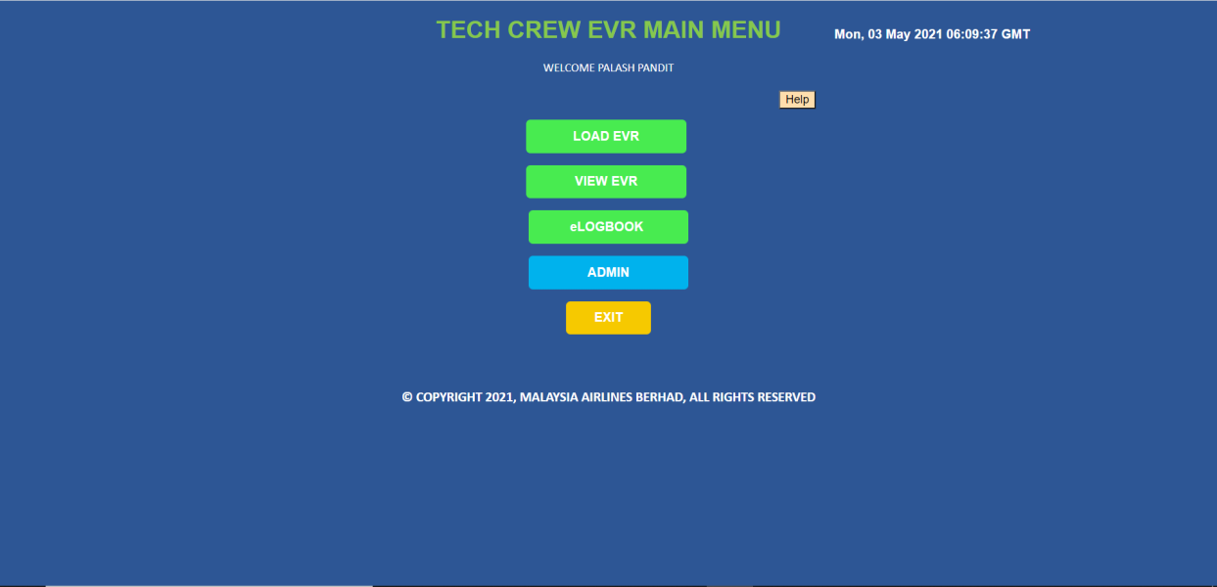

1. **eLOGBOOK features:**

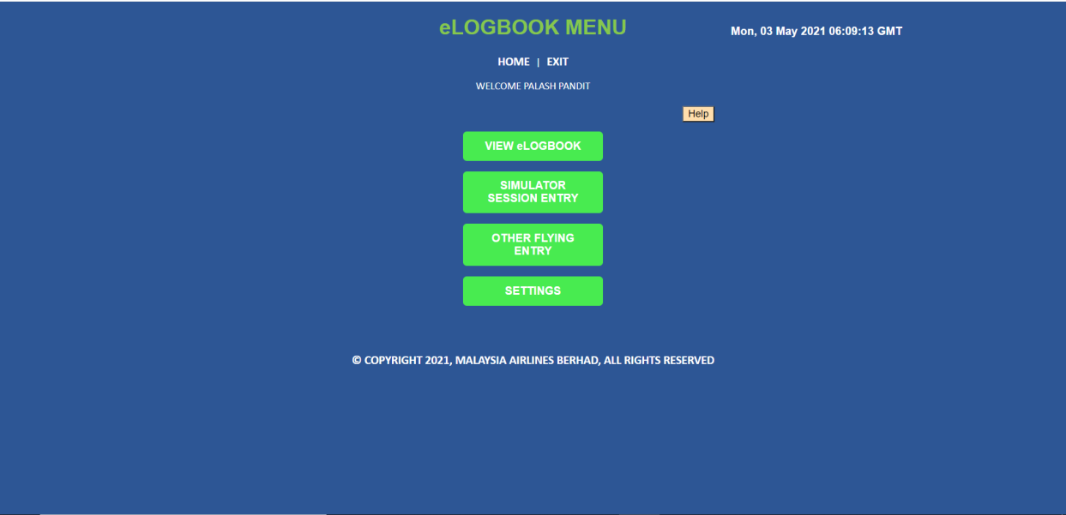

1. **VIEW eLOGBOOK** for **User** to **view the logbook details in between selected months**:

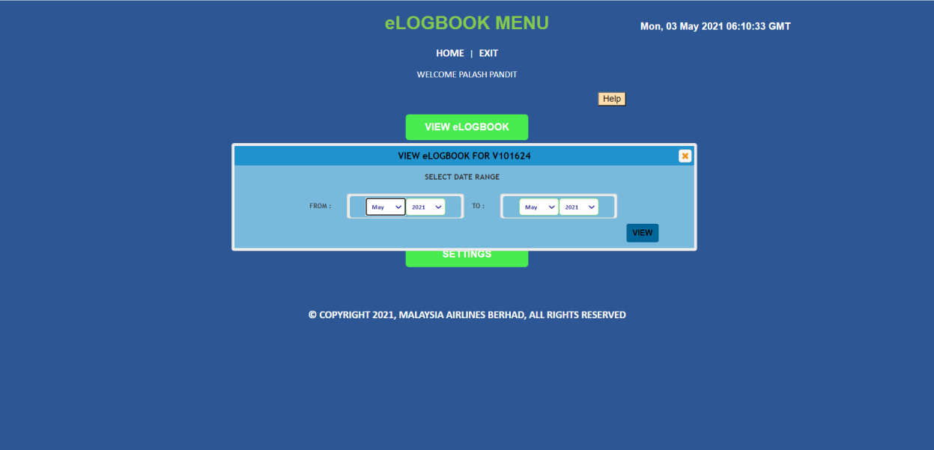

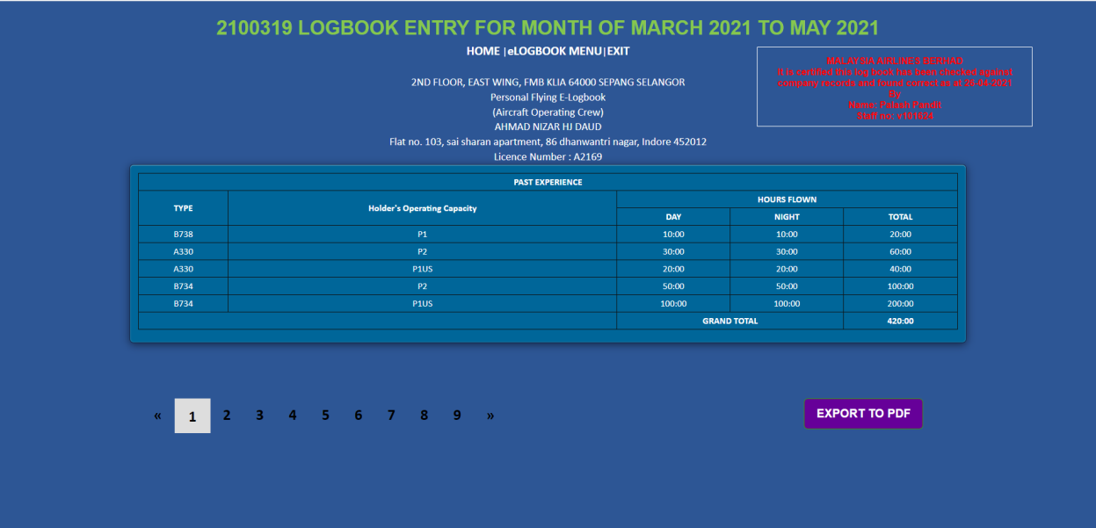

1. Export to PDF button export the whole report in PDF:

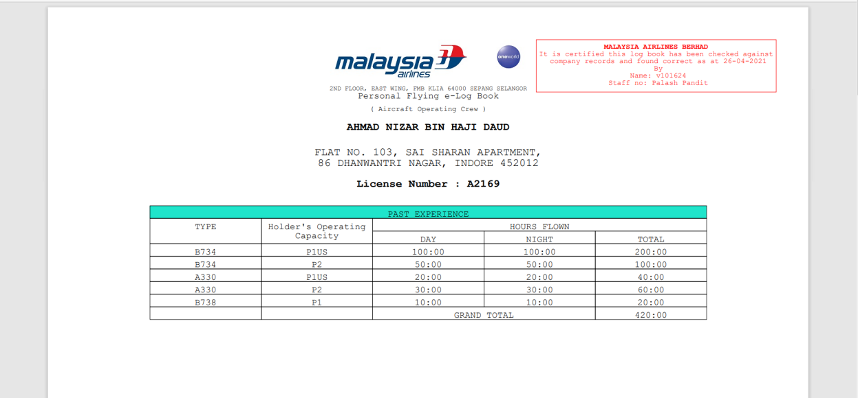

1. Simulator session entry for user to enter their simulator data (user can add multiple entries at once:

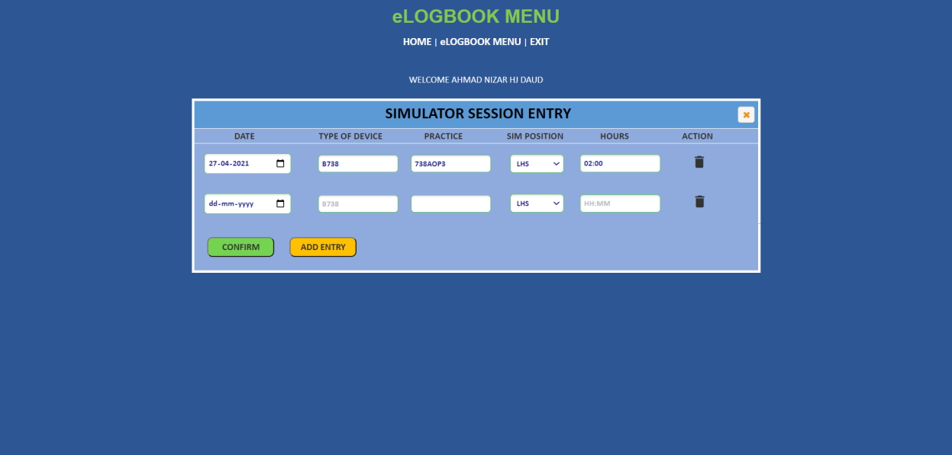

1. Other flying information for user to enter their other flying data (user can add multiple entries at once:

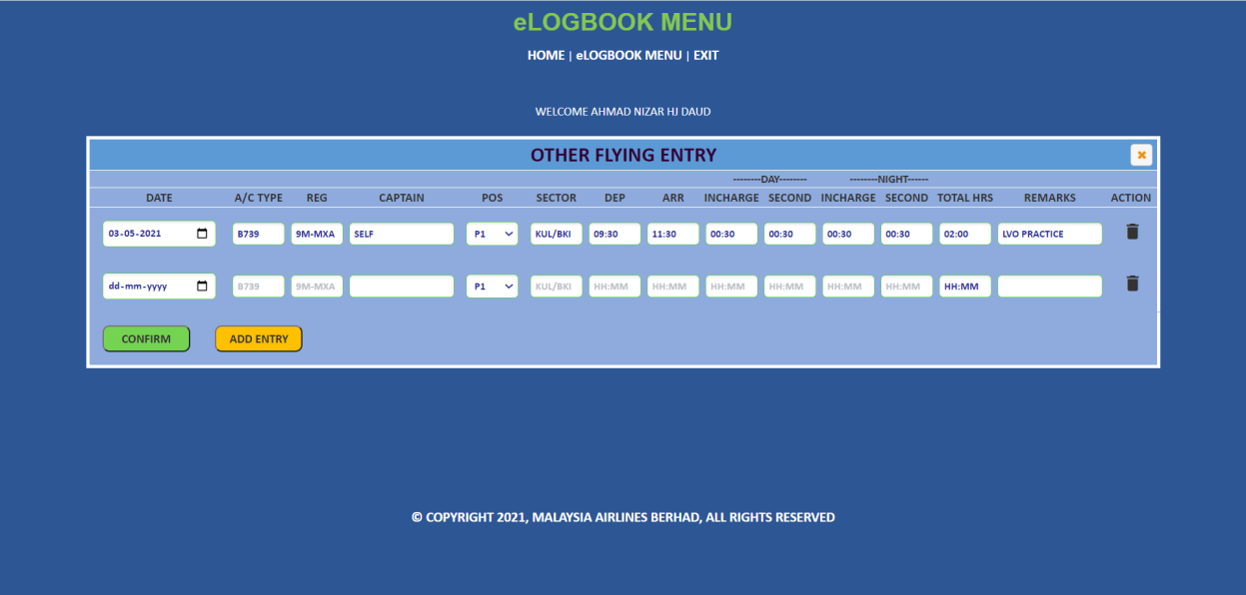

1. Settings screen with previous flying experience entry, update address and update license number:

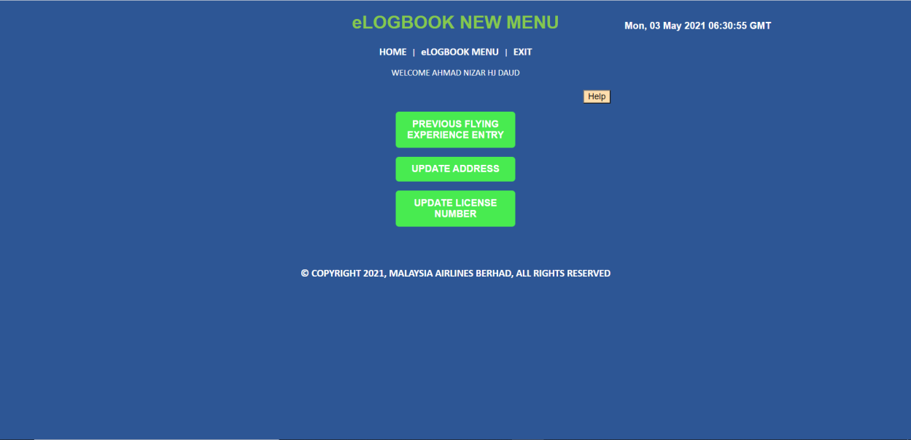

1. Previous flying experience entry for user to enter their previous experience data (user can add multiple entries at once):

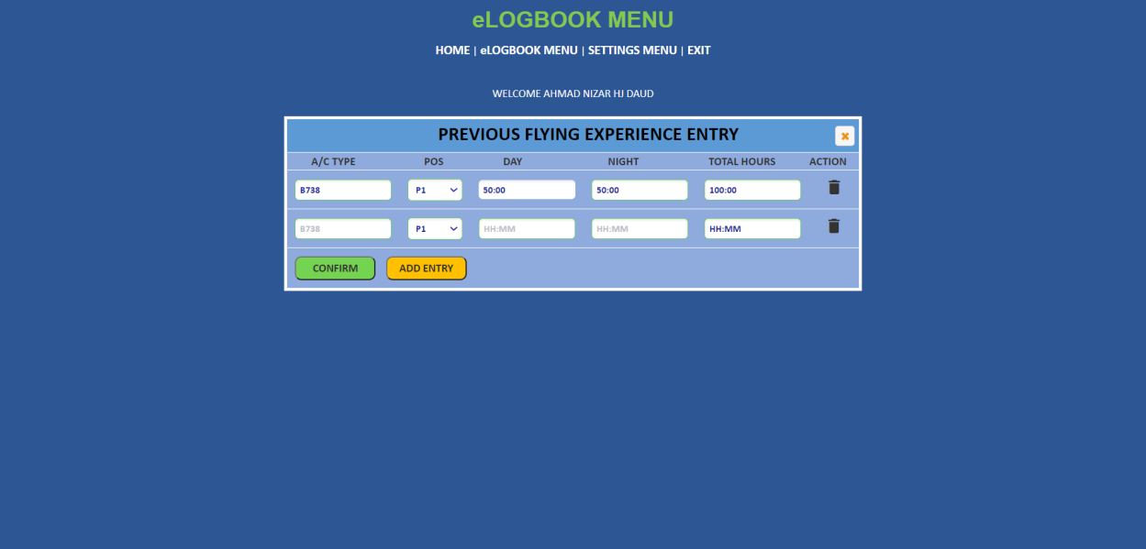

1. Update address for user to update their address. If user has to add their address for the first time, current address would be empty and new address field will add the address as new one.

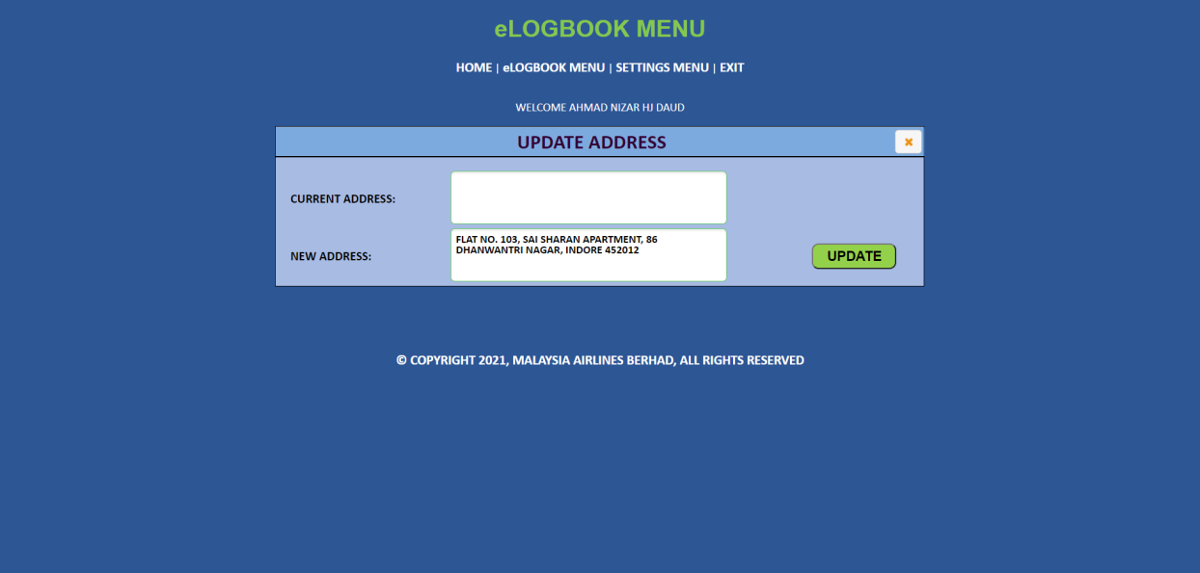

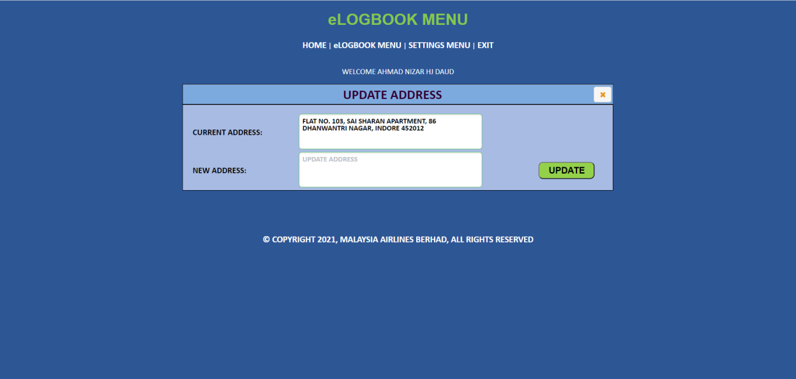

1. Update license number for user to update their license number. If user has to add their license number for the first time, present license number would be empty and new license number would add it as new one. Here new license number is inserted in the database. We are keeping old and new both license number in the database.

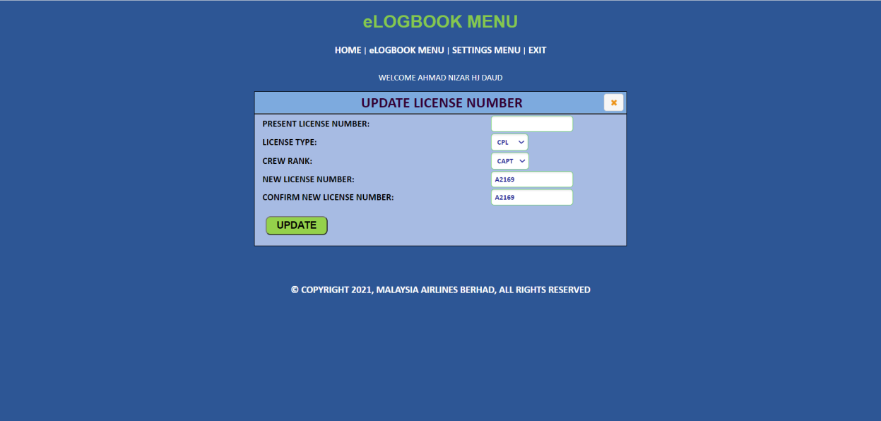

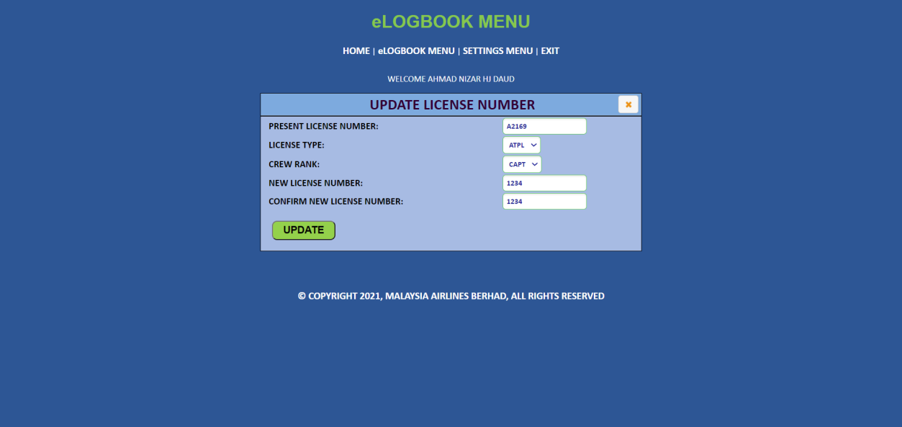

**4.9.2.2** **ADMIN**

User can see the features/buttons as per the access granted.

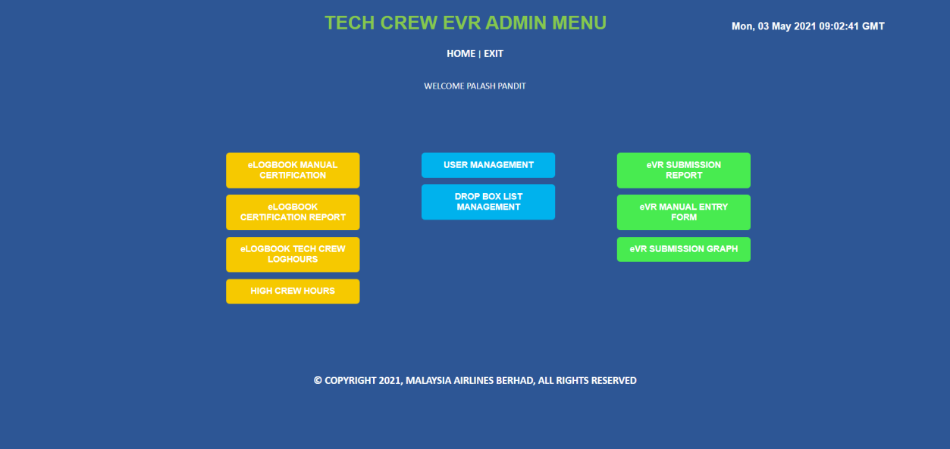

1. eLogbook manual certification for admin to add the staff manual certification details. Manual certification can be only 1 per user:

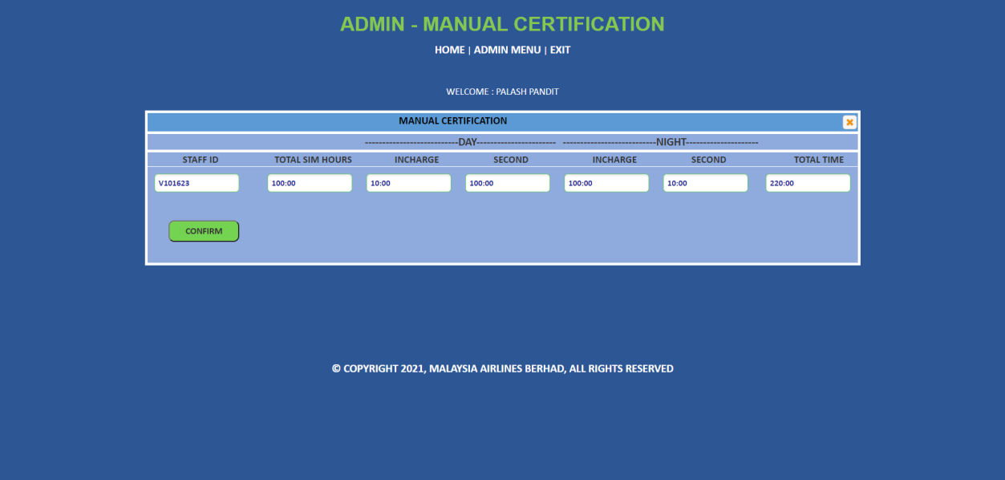

1. eLogbook certification report for admin to get the individual and monthly report:

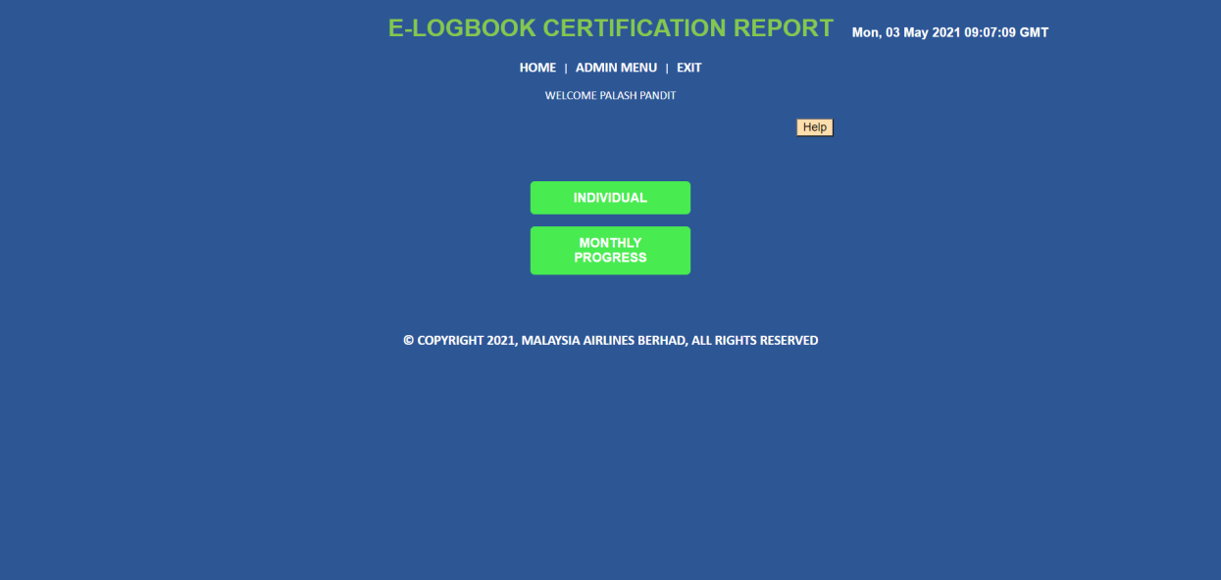

1. Individual for admin to the report for a single user for selected months:

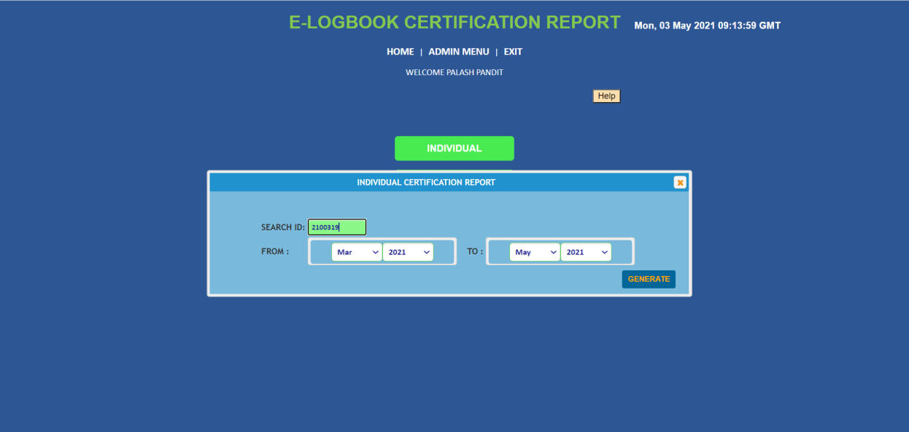

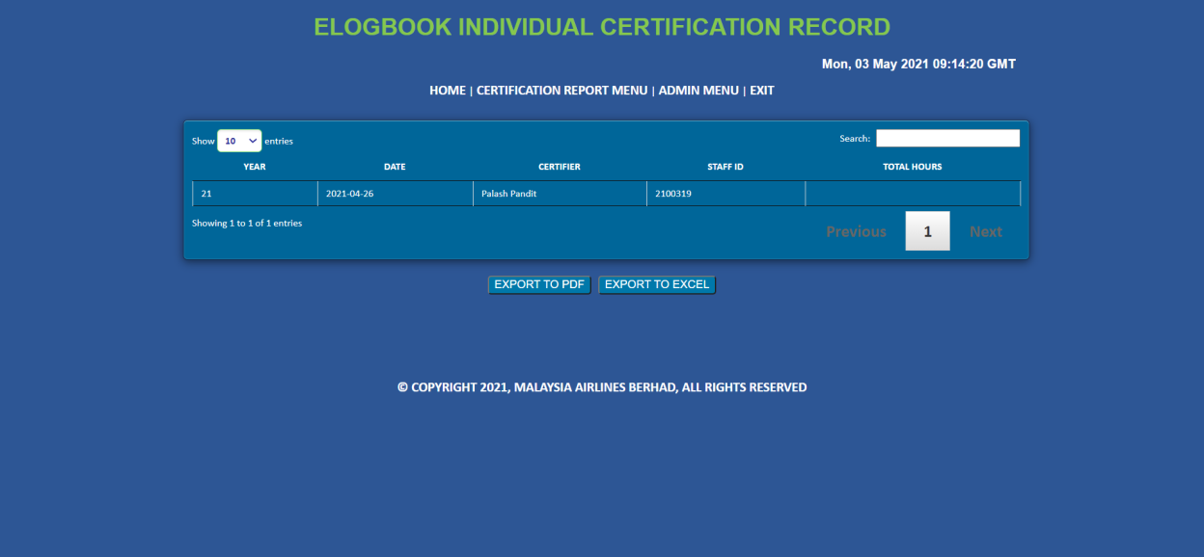

1. Monthly report to generate all the certification report for the selected months:

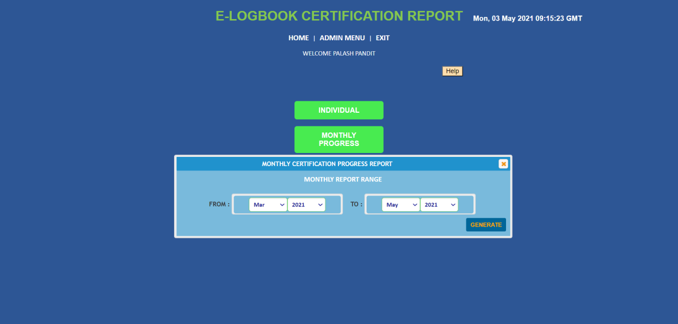

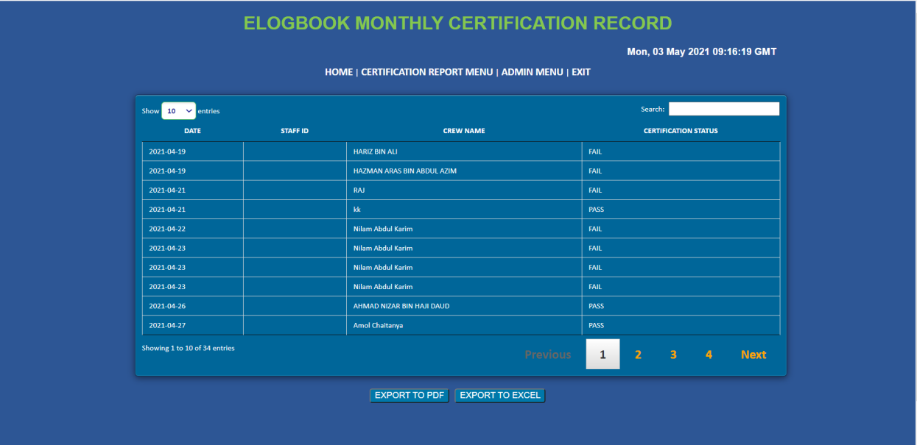

1. eLogbook tech crew loghours for admin to get the report for the particular user for selected months:

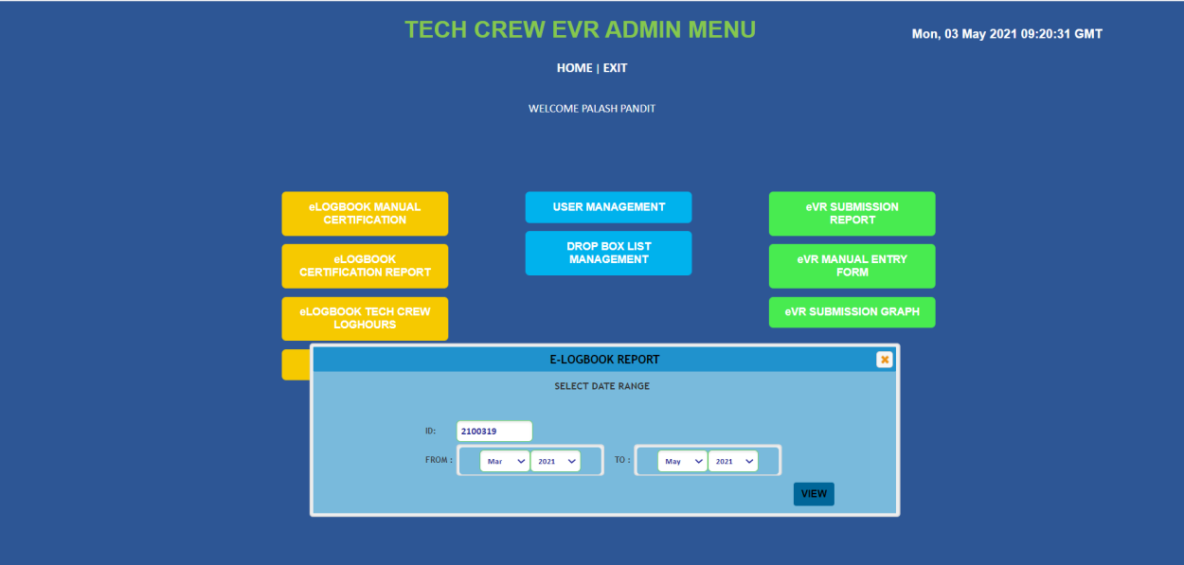

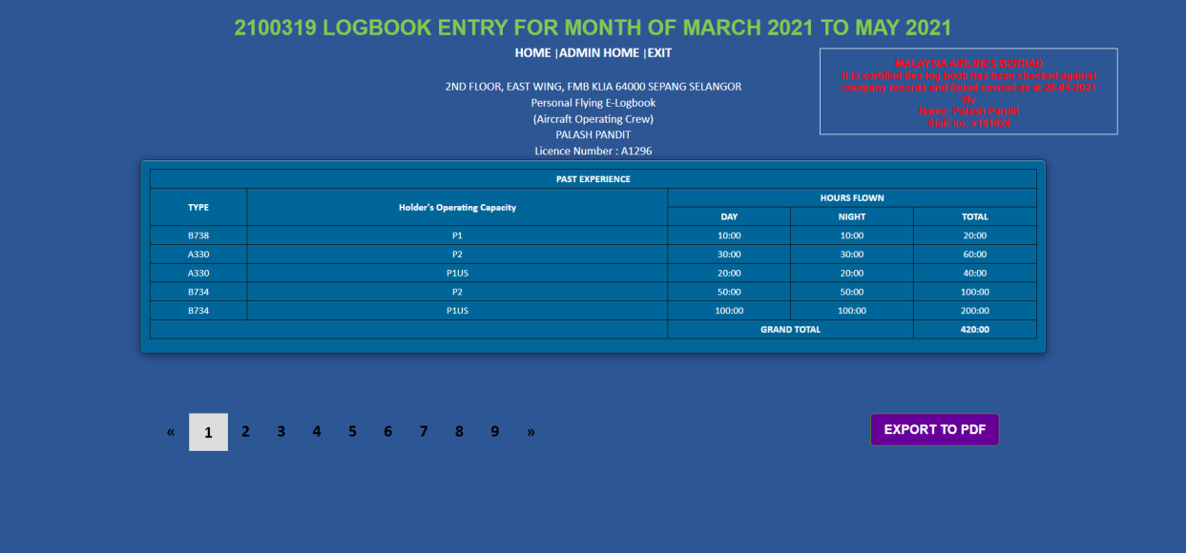

1. Highcrew hours for admin to get the data of the for the particular date with the selected fleet type and max loghours limit.

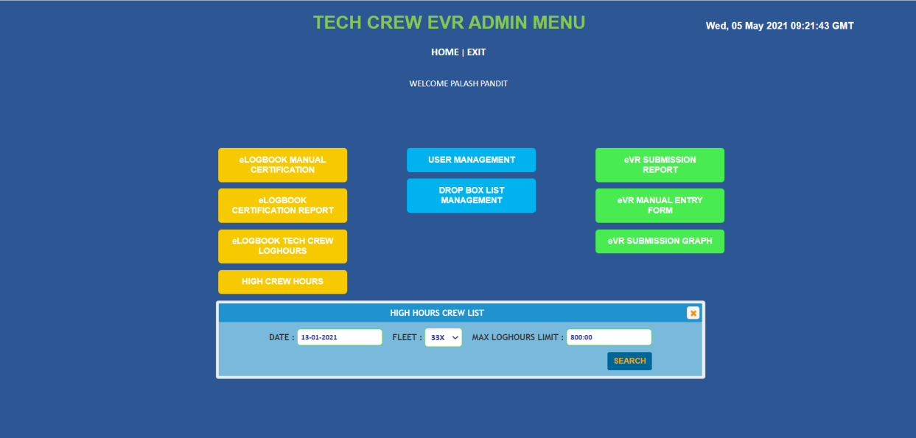

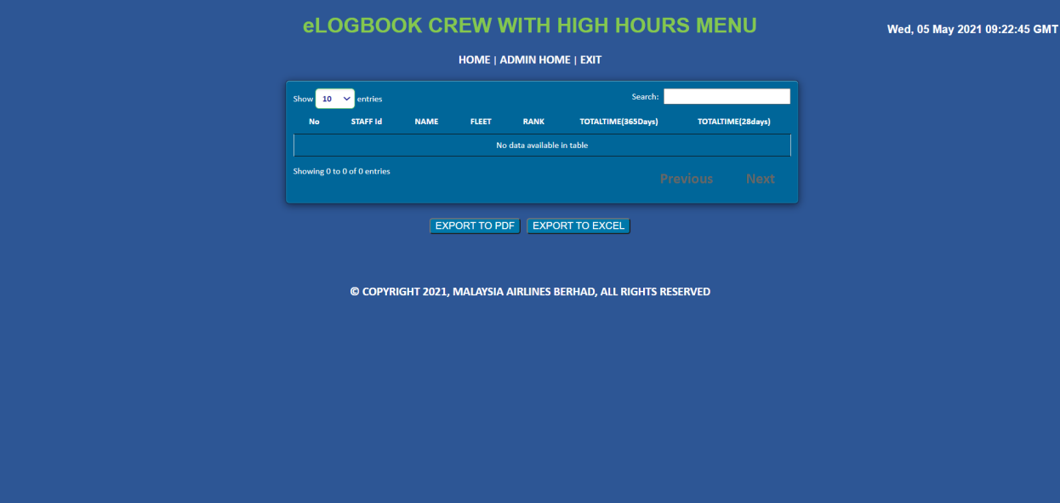

1. eVR submission report is for getting the non submitted eVR forms for the staff for the selected fleet between the selected dates.

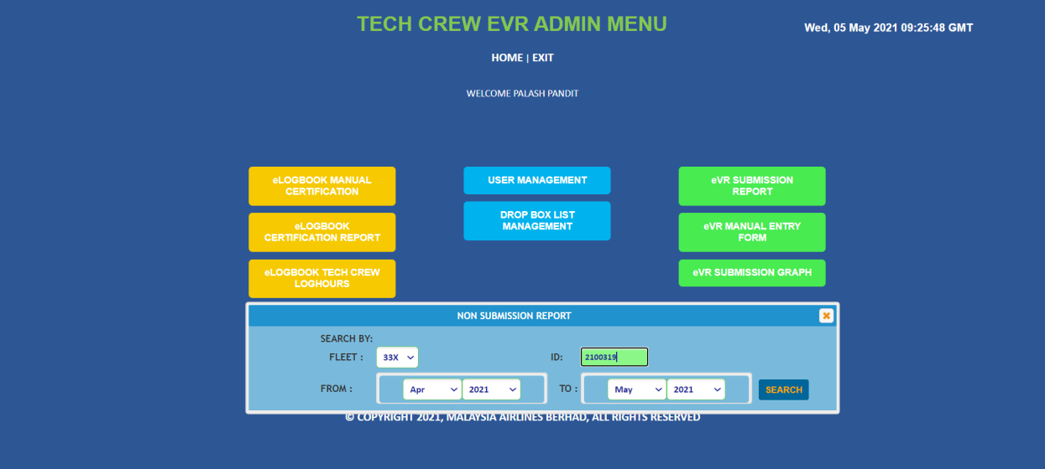

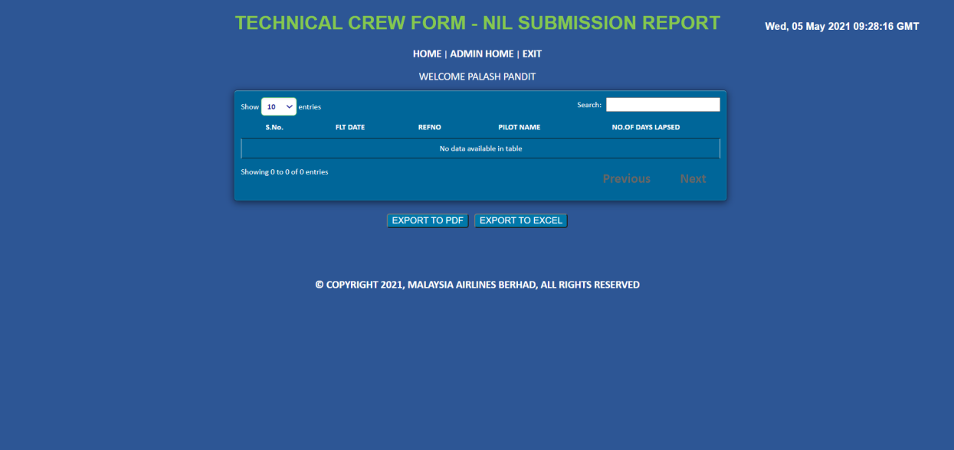

* + - 1. **SCHEDULED JOBS**

1. Crew list: Fetching the missing crew data for the scheduled flights. Mail is sent to NCMS team with the flight details.
2. Certification: To check the certification for the particular staff. It will check the certification for every staff member in every 4 month. If certification passes, it will send out a mail to the staff member with certification pass details and elogbook report as attachment. If certification fails it will send out a mail to the staff member stating that the certification is failed and will remind the staff member to submit their peding eVR forms. If staff member does’t submit peding eVR forms for the next 3 days, our job will send a mail every day. On the 3rd day it will send out a mail to the head team stating the same.
3. Sumission reminder: This job is to remind the staff member to submit their eVR form. 1st reminder will be sent within 12 hours lapsed with the title as 1st reminder. 2nd reminder will be sent within 18 hours lapsed with the title as ‘final’. Last reminder will be sent in 24 hours with title as ‘Nil’. Final and Nil reminders will have the other operating crew members in the CC. Ref number will be auto generated.
4. Failed certifications: This job will get all the failed certifications for that day and send it to the admin team.

# ACCESSING THE APPLICATION

Users can access the application by using the below URLin their browsers.

**EVR CCF:**

PROD:

* + - https://evr.malaysiaairlines.com/EVR\_CCF/JSP/LoginForm.jsp
    - <http://evr.mas.net/EVR_CCF/JSP/LoginForm.jsp>

UAT:

* + - <http://3evrapp1.mas.net:8080/EVR_CCF/JSP/LoginForm.jsp>

**EVR TCF:**

PROD:

* + - https://evr.malaysiaairlines.com/EVR\_TCF/JSP/LoginForm.jsp
    - <http://evr.mas.net/EVR_TCF/JSP/LoginForm.jsp>

UAT:

* + - <http://3evrapp1.mas.net:8080/EVR_TCF/JSP/LoginForm.jsp>

# CONTRACT MANAGEMENT

|  |  |  |
| --- | --- | --- |
|  | **Contract** | **Parties** |
| 1. | Solution Delivery Contract And Maintenance & Support Services | Signed between MAB and ATOS |

Table 18

# HANDOVER ITEMS

The following documents / items will be handed over to Operations together with this System Operation Document during the Handover session.

* Project cutover plan
* UAT signoff by Business Owner
* EVR User Guide
* EVR Technical Manuals and Installation Guides
* Softcopy of this System Operations Document

# INFORMATION SECURITY

Single Sign -On (SSO):

EVR application is integrated with SSO and permits a user to enter credentials in order to access multiple applications as CCF and TCF.

User for both applications can eliminate further sign-in when they switch applications in particular sessions.

SSO is a single sign-on model in which an end user's EVR credentials are encrypted and securely stored in the PingOne Cloud User Store. End users perform a one training of the applications using the PingOne browser extension to collect the application credentials. Once those are stored in PingOne, future logins are seamless for the end user from this browser.

Credentials will be automatically retrieved, decrypted, and entered into the sign-in form when the user requests an application's login page.  This frees the end user from having to remember passwords for multiple applications, and streamlines the process of accessing each application.

SSO relies on application credentials that are encrypted and maintained within the Cloud User Store.

### 4.13.1. Audit And Compliance Requirements

| **Activity** | **Frequency** | **Responsible Party** |
| --- | --- | --- |
| Perform ID review every quarter and submit result to IRS | Quarterly | ID Admin |
| Update user access matrix and submit to IRS | Yearly | System Owner |
| Install Critical Security Patches for the application and submit report to IRS | Quarterly | System Owner |
| Perform Backup restoration | Yearly | System Owner |
| Review & update security documentation and submit to IRS:   * Super/privilege IDs and access * Security Controls Setting * Audit Logs setting * System bypass * List of connections and integration * List of used ports * Data encryption setting * Application/system schematic diagram | Yearly | System Owner |

Table 19

### 4.13.2. Password And Policy Compliance

|  |  |  |  |  |
| --- | --- | --- | --- | --- |
|  | **Password Policy Requirements** | **Yes** | **No** | **Remarks** |
|  | Password length at least 8 characters (minimum) | Yes |  | Uses LDAP authentication for login |
|  | Alphanumeric | Yes |  |  |
|  | Change temporary password at first logon | Yes |  |  |
|  | Password expiry = 90 days (maximum) | Yes |  |  |
|  | Password reuse generation = 5 (minimum) | Yes |  |  |
|  | Account lock out after 3 failed login attempts | Yes |  |  |
|  | Application shall disconnect or suspend inactive sessions= 15 Minutes | Yes |  |  |
|  | Wrong password shall be recorded in an audit log | Yes |  |  |

Table 20

### 4.13.3. User Access Matrix

The following table shows the user access matrix of EVR application

|  |  |  |  |  |
| --- | --- | --- | --- | --- |
| **USER TYPE** | **ACCESS LEVEL** | | | |
| **Submit** | **View** | **Update** | **Delete** |
| Super Admin | N.A | N.A | N.A | N.A |
| Admin | N.A | N.A | N.A |  |
| User | X | X |  |  |

Table 21

# DOCUMENTATION AND REFERENCES

|  |  |  |
| --- | --- | --- |
|  | **Document** | **Location of source** |
| 1 | System Operation Document | [https://mabitdept.sharepoint.com/sites/MyPulse/InformationTechnology/ServiceDeliveryManagement/](https://mabitdept.sharepoint.com/sites/MyPulse/InformationTechnology/ServiceDeliveryManagement" \t "_blank) |
| 2 | User Guide | [https://mabitdept.sharepoint.com/sites/MyPulse/InformationTechnology/ServiceDeliveryManagement/](https://mabitdept.sharepoint.com/sites/MyPulse/InformationTechnology/ServiceDeliveryManagement" \t "_blank) |

Table 22

INTENTIONALLY LEFT BLANK

# APPENDIX



**Change Requests:**

|  |  |  |  |  |  |
| --- | --- | --- | --- | --- | --- |
| **S.No** | **Change Request#** | **Implementation Date** | **Change Title** | **Fix Included?** | **Impacted Version** |
| 1 | NCR4545 (EVR-TCF) | 12-Dec-17 | Load Form changes | Yes | V1.4 |
| 2 | CHG0011941(EVR-TCF) | 28-Feb-18 | E-Logbook Changes | Yes | V1.4 |
| 3 | CHG0011895(EVR-CCF) | 14-Feb-18 | Database query change | Yes | V1.4 |
| 4 | CHG0016966 | 25-Jan-2020 | Include MH5000 series flights into EVR | Yes | V1.5 |
| 5 | CHG0017796 | 02-April-2020 | EVR- mandatory Arrival Fuel value in the EVR form submission | Yes | V1.5 |
| 6 | CHG0018159(EVR-TCF) | 21-May-2020 | EVR Submission Graph | yes | V1.5 |
| 7 | CHG0018160(EVR-TCF) | 21-May-2020 | Missing crew Info- Auto Schedule Implementation | Yes | V1.5 |
| 8 | CHG0020463(EVR-TCF) | 11-Mar-2021 | EVR Form Skedid insertion by using UTC instead of MLT | Yes | V1.5 |
| 9 | CHG0020804(EVR-CCF) | 22-Apr-2021 | EVR Cabin Crew -Report Generation | Yes | V1.5 |
| 10 | CHG0022477(EVR-TCF) | 06-Jan-2022 | Blank EVR page on Company iPad | Yes | V1.5 |

Table 23

**PATCH MANAGEMENT REPORT**

Application : \_\_\_\_\_\_\_\_\_\_\_\_\_\_\_\_\_\_\_\_EVR\_\_\_\_\_\_\_\_\_\_\_\_\_\_\_\_\_\_\_\_\_\_\_\_\_\_\_\_\_\_\_

Owner **: \_\_\_\_\_\_\_\_\_\_\_\_\_\_\_\_\_\_\_\_\_\_\_\_\_\_\_\_\_\_\_\_\_\_\_\_\_\_\_\_\_\_\_\_\_\_\_\_\_\_\_\_\_\_**

|  |  |
| --- | --- |
| **Date** | **Patch / Service Pack Applied** |
| NIL | NIL |
|  |  |
|  |  |
|  |  |

**Prepared By: Approved By:**

**.................................................... ....................................................**

**System Admin System Owner**

**BACKUP RESTORATION REPORT**

Application : \_\_\_\_\_\_\_\_\_\_\_\_\_\_\_\_\_\_\_\_\_\_\_\_\_\_\_\_\_\_\_\_\_\_\_\_\_\_\_\_\_\_\_\_\_\_\_\_\_\_\_\_\_\_

Owner **: \_\_\_\_\_\_\_\_\_\_\_\_\_\_\_\_\_\_\_\_\_\_\_\_\_\_\_\_\_\_\_\_\_\_\_\_\_\_\_\_\_\_\_\_\_\_\_\_\_\_\_\_\_\_**

|  |  |
| --- | --- |
| **Date** | **Status of Restoration** |
| **NIL** | **NIL** |
|  |  |
|  |  |
|  |  |

**Prepared By: Approved By:**

**.................................................... ....................................................**

**Backup Admin System Owner**

**NON COMPLIANCE REPORT**

Application : \_\_\_\_\_\_\_\_\_\_\_\_\_\_\_\_\_\_\_\_\_\_\_\_\_\_\_\_\_\_\_\_\_\_\_\_\_\_\_\_\_\_\_\_\_\_\_\_\_\_\_\_\_\_

Owner **: \_\_\_\_\_\_\_\_\_\_\_\_\_\_\_\_\_\_\_\_\_\_\_\_\_\_\_\_\_\_\_\_\_\_\_\_\_\_\_\_\_\_\_\_\_\_\_\_\_\_\_\_\_\_**

|  |  |  |
| --- | --- | --- |
| **Date** | **Reference Number** | **Description** |
|  |  |  |
|  |  |  |
|  |  |  |
|  |  |  |

**Prepared By: Approved By:**

**.................................................... ....................................................**

**System Admin System Owner**

**END OF DOCUMENT**